Approval Workflow
This document outlines the end-to-end approval workflow for handling requests initiated by Engineers and Remote Hands teams. It ensures that all requests follow a standardized, transparent, and auditable path, covering regular approvals, over-budget scenarios, delegation handling, notifications, and escalation rules.
The objective is to:
- Streamline approvals across all site codes.
- Ensure timely visibility and accountability at each stage.
- Provide clarity on delegation and escalation mechanisms.
- Maintain consistency for both regular and over-budget workflows.

1. Request Initiation
- Engineer Path: A request is raised by an Engineer.
- Remote Hands Path: A request is raised by the Remote Hands team.

2. Approval Flow (Regular)

Engineer Path
- Engineer raises requests.
- Chief Engineer approval.
If the Chief Engineer is unavailable, the Lead/Assistant Engineer can click on the Delegate option, provide a valid comment, and then approve.
- DCO Approval.

Remote Hands Path
- Remote Hands Team Member raises request
- Remote Hands Manager Approval.
If the Remote Hands Manager is unavailable, the Remote Hands Lead can click on the Delegate option to provide a valid comment and then approve.
- DCO Approval.

3. Over-Budget Path
- Engineer Path: Engineer → Chief Engineer (delegation Lead/Asst Engineer) → DCO → MTM → Property Manager (delegation MPM).
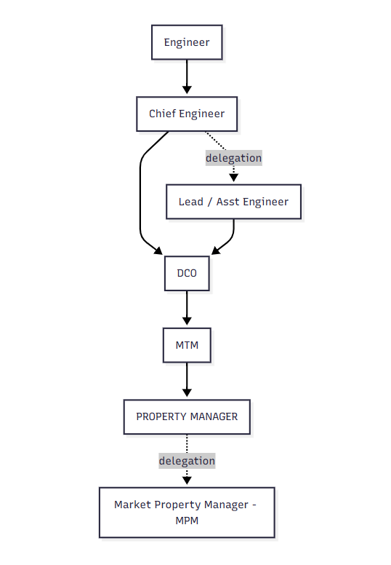

- Remote Hands Path: Remote Hands → Remote Hands Manager (delegation Remote Hands Lead) → DCO → MTM → Property Manager (delegation MPM).
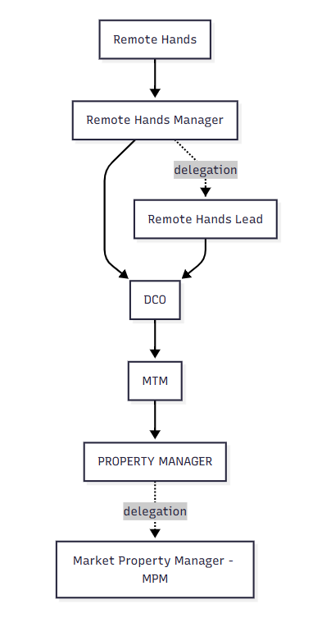
On Rejection: A notification will be sent along with rejection comment to the submitter, Previous approved approvers

4. Delegation Rules
- Delegation Button: Lead/Assistant Engineer can click on the delegate option, enter a valid comment, and approve on behalf of the Chief Engineer.
- Mandatory Comment: Every delegation must include a clear and valid comment.

5. Property Assistant & PO Handling
- After DCO approval, Property Assistant raises PO number.
- Within 3 days of DCO approval, PO must appear in the system.
- If PO does not appear, an escalation process is triggered.
- After delegation, the workflow continues as per the standard approval chain.

6. Escalation Path (If PO Not Approved)
- After 72 hours – Escalate to Property Manager
- After 96 hours – Escalate to DCO
- After 120 hours – Escalate to Market Property Manager and Market Technical Manager
- After 144 hours – Escalate to GMMO
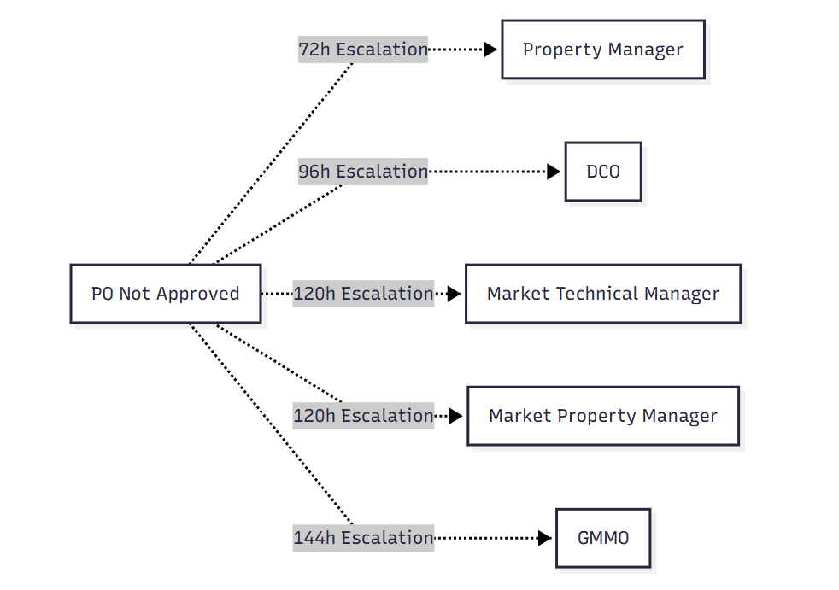

7. Other Notes
- The same workflow applies to all site codes.
- Additional Budget / Transfer: Follows the same approval workflow (starting with a budget request).
- PO Number Source: PO number is obtained from the Yardi system.

8. Phase 2;
- Send out POs to vendor and site teams automatically.
- A weekly report of outstanding PO (pending approval, in progress, rejected, etc.) status can be provided; we can eliminate the MPM and GMMO escalations. If so, we can determine who it goes too. This is a much cleaner approach.

